Water World II
Time Limit: 1000 mSec Memory Limit : 32768 KB
Problem Description
The well known PC game engineer Kevin Flynn designed a new game:Water World II.Player can enters the Virtual Water World and build the world through this game.
Jack is the Administrator of Virtual World.He is responsible for water conservation project.Now Kevin gives him a big mission:building a reservoir made with thousands of moutain.

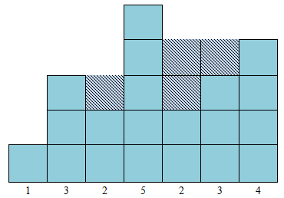
Every mountain's width is 1 unit and the hight is Hi .Mountain numbered from left to right.The valley between two moutains can hold water.
Jack can move the leftmost mountain to the rightmost for several times(include zero).
In order to complete the project,Kevin provide k unit building materials for Jack .Jack can add them to some mountain’s top.
Input
The input consists of several test cases.
For each case,there are two integer n,k in first line.(0<n<=10000,0<k<=10).
Then follow one line there are n integers indicate that the ith moutain's height is Hi.the moutain start from left to right.(0<Hi<10000000)
Output
For each case print a ingeter number,indicate the maxmum of water it can hold.
Sample Input
3 0
2 3 1
7 2
1 3 2 5 2 3 4
Sample Output
1
11
Hint
Case 1:
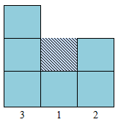
Case 2:
